A Summer Internship Project Report on
“ShopSC – Premium E-Commerce WebApplication”

Submitted in partial fulfilment of the Requirements for the award of the Degree of

BACHELOR OF TECHNOLOGY

IN

COMPUTER SCIENCE & ENGINEERING

By
A.SETHU SRINIDHI
25EG505C03
Under the Guidance of
_____________________________



Department of Computer Science &Engineering ANURAG UINVERSITY

GHATKESAR (M), MEDCHAL DISTRICT,
Hyderabad-88
Academic Year: 2025-2026

ANURAG UNIVERSIY

Hyderabad-500 088
Department of Computer Science & Engineering

CERTIFICATE

I, A.SETHU SRINIDHI, bearing hall ticket number, 25EG505C03, hereby declare that the project report entitled “SHOPSC-Premium E-Commerce WebApplication”, Department of Computer Science & Engineering, Anurag University, Hyderabad, is submitted in partial fulfilment of the requirement for the award of the degree of Bachelor of Technology in Computer Science & Engineering.
This is a record of bonafide work carried out by me and the results embodied in this project report have not been submitted to any other university or institute for the award of any other degree or diploma.

Signature of The Guide A.SETHU SRINIDHI
________________________ 25EG505C03

ACKNOWLEDGMENT

I would like to express my sincere thanks and deep sense of gratitude to project supervisor _____________________, for his constant encouragement and inspiring guidance without which this project could not have been completed. His critical reviews and constructive comments improved our grasp of the subject and steered to the fruitful completion of the work. His patience, guidance and encouragement made this project possible.

I would like to express my sincere gratitude to Dr. Archana Mantri, Vice Chancellor, Anurag University and Dr. P. Bhaskara Reddy, Registrar, Anurag University for their encouragement and support.

I would like to express my special thanks to Dr. V. Vijaya Kumar, Dean School of Engineering, Anurag University, for his encouragement and timely support in our B.Tech program.

I would like to acknowledge my sincere gratitude for the support extended by Dr. G. Vishnu Murthy, Dean, Department of Computer Science Engineering, Anurag University. We also express my deep sense of gratitude to Dr. P. Ravinder Rao, academic coordinator, whose research expertise and commitment to the highest standards continuously motivated us during the crucial stage of our project work.

A.SETHU SRINIDHI
25EG505C03

DECLARATION

I hereby declare that the project entitled “SHOPSC-Premium E-Commerce WebApplication ”submitted to the Department of Computer Science and Engineering is an original work carried out by us under the guidance of ___________________. The work presented in this report has not been submitted elsewhere for the award of any degree.

A.SETHU SRINIDHI
25EG505C03

TABLE OF CONTENTS
TOPICS PAGE NO.
Acknowledgement i
Declaration ii
Abstract iii
- Introduction
- Problem Statement
- Objectives
- Scope of the Project
- Existing System
- Proposed System
- Software & Hardware Requirements
- System Design
- Flowchart & Algorithm
- Modules Description
- Implementation
- Results / Output Screens
- Advantages & Limitations.
- Future Enhancements
- Conclusion
- References
- Source Code

ABSTRACT
Electronic commerce has become the dominant channel through which modern retail businesses reach their customers, and the ability to design, build, and reason about a complete e-commerce platform is therefore a core skill for a software engineer. This project, ShopSC (internally configured with the database name ShopSC), is a full-stack web application that implements the principal workflows of an online luxury retail storefront: user registration and authentication, OTP-based password recovery, product catalogue browsing, cart management, checkout, order placement, and administrative product management.
The system is built using the MERN stack – MongoDB as the NoSQL document database, Express.js as the backend web framework running on the Node.js runtime, and React (bootstrapped with Vite) as the single-page application framework for the client. The backend exposes a RESTful JSON API under the /api prefix and uses JSON Web Tokens (JWT) for stateless session authentication, with bcrypt.js used to one-way hash user passwords before they are persisted. The frontend is implemented as a set of modular functional React components (Navbar, Auth, Shop, Cart, Checkout, Admin, and ForgotPassword) that communicate with the backend using the Axios HTTP client and manage page navigation through local component state rather than a client-side router.
The data layer comprises four Mongoose collections – Users, Products, Carts, and Orders – modelled to keep each concern independent: a cart entry stores a denormalised snapshot of product title, price, and image so that historical cart and order data remains stable even if the underlying product listing is later edited or removed. The checkout workflow aggregates a user's cart items, computes the order total, simulates a payment gateway authorization, persists an Orders document, and atomically clears the user's cart.
This report documents the complete software development life cycle followed in building ShopSC: the problem statement and objectives, a survey of the existing landscape and the proposed system's advantages, the functional and non-functional requirements, system design artifacts (architecture, ER, DFD, use-case, and flowcharts), module-wise implementation detail with source code explanation, testing strategy, results, advantages and limitations of the present implementation, and a roadmap of future enhancements such as real payment gateway integration, role-based authorization middleware, and order tracking.

TABLE OF CONTENTS

1. INTRODUCTION
Retail commerce has been undergoing a sustained shift away from physical storefronts and toward web- and mobile-based shopping experiences for more than two decades, and this shift has only accelerated in recent years. For a customer, an online store must feel fast, trustworthy, and easy to navigate; for the business operating it, the same platform must be secure, maintainable, and simple to extend with new products, payment options, and promotional features. Building such a platform from the ground up – rather than simply configuring an off-the-shelf storefront builder – is one of the best ways for a student of computer science to internalise the practical concerns of full-stack web development: request/response cycles, authentication, database schema design, state management, and user-interface design.
This project, named ShopSC at the presentation layer and configured internally with the database name ShopSC, is a full-stack e-commerce web application built on the MERN stack (MongoDB, Express.js, React, Node.js). It models a curated, premium online storefront in which every listed product is priced in the higher end of the retail spectrum (from approximately ₹10,000 up to ₹1,99,999), giving the catalogue and checkout flow a luxury-retail character. The application supports the complete customer journey – registration, login (with OTP-based password recovery), product browsing, cart management, and checkout – as well as a lightweight administrative interface for adding new products to the catalogue.
The remainder of this report documents the problem this project addresses, the objectives and scope that were defined for it, a comparison against existing systems, the proposed system's design and architecture, the software and hardware environment used to build and run it, the detailed system design artifacts (data flow diagrams, entity-relationship diagram, use-case diagram, and flowcharts), the implementation of each module with reference to the actual source code, the testing performed, the resulting screens, and a discussion of the system's advantages, limitations, and avenues for future enhancement.

1.1 Problem Statement
Small and medium-sized retail businesses that wish to sell premium or luxury goods online frequently face one of two unsatisfactory options. The first is to adopt a generic, heavily templated e-commerce platform (such as a hosted storefront builder) that is quick to set up but offers little control over the underlying data model, authentication mechanism, or user experience, and that typically carries recurring subscription or transaction fees. The second is to commission a fully bespoke system, which offers complete control but is expensive and slow to build if every concern – authentication, catalogue management, cart logic, and order processing – must be designed from first principles.
There is a need, therefore, for a reference implementation that demonstrates how the core building blocks of an e-commerce platform – secure user accounts, a flexible product catalogue, a persistent shopping cart, and an auditable order history – can be implemented cleanly using a modern, widely supported, and cost-free technology stack. The problem this project addresses is precisely that: to design and implement a minimal yet functionally complete e-commerce web application covering authentication, catalogue browsing, cart management, and checkout, using the MERN stack, in a way that is easy to understand, extend, and deploy.

1.2 Objectives
The specific objectives defined for this project were:
- To design a normalised yet practical MongoDB data model covering users, products, cart items, and orders, using Mongoose schemas with appropriate validation and default values.
- To implement secure user registration and login using one-way password hashing (bcrypt.js) and stateless session management using JSON Web Tokens (JWT).
- To implement an OTP (One-Time Password) based password-recovery workflow that allows a user to reset a forgotten password without administrator intervention.
- To build a RESTful Express.js API exposing all catalogue, cart, authentication, and order operations under a consistent /api route prefix.
- To build a responsive, componentised React (Vite) single-page application front-end that consumes this API using Axios, with dedicated components for navigation, authentication, the product catalogue, the cart, checkout, and basic administration.
- To implement an end-to-end checkout flow that aggregates a user's cart, computes the order total, simulates payment authorization, persists an order record, and clears the cart transactionally.
- To document the system's architecture, data flow, and module-level design using standard software engineering diagrams (DFD, ER diagram, use-case diagram, and flowcharts).
- To evaluate the resulting system against its objectives and to identify limitations and concrete future enhancements.

1.3 Scope of the Project
The scope of the project covers the design, implementation, and testing of a two-tier client/server web application (a React client and an Express/Node.js server, backed by a MongoDB database) that supports the following functional areas:
- User account management: registration, login, logout, and OTP-based password reset.
- Product catalogue: viewing all available products, each with a title, description, price, and image.
- Shopping cart: adding items to a per-user cart, viewing cart contents and the running total, adjusting quantities, and removing individual items.
- Checkout and orders: submitting a shipping address and payment details, simulating payment authorization, creating an order record, and clearing the cart upon success.
- Basic administration: a simple form-based interface that allows a privileged user to add new products to the catalogue.
The following areas are explicitly outside the scope of the current implementation, though they are discussed as future enhancements in Chapter 14: integration with a real, certified third-party payment gateway (e.g. Razorpay, Stripe); role-based route protection (middleware that verifies the JWT and restricts admin-only endpoints); order tracking and shipment status updates; product search, filtering, and pagination at the API level; product reviews and ratings; and a production-grade deployment pipeline (containerisation, CI/CD, and managed hosting).

1.4 Existing System
Prior to undertaking this project, the available alternatives for standing up a small online store generally fell into three categories, each with limitations relevant to this project's goals:

1.4.1 Hosted Storefront Platforms
Platforms such as hosted storefront builders allow a merchant to launch a store quickly using pre-built themes and a managed backend. While convenient, these platforms abstract away the underlying data model and authentication logic entirely, offer limited customisation of business rules, and typically charge recurring subscription and transaction fees. They are not suitable as a learning vehicle for understanding how authentication, cart state, or order processing actually work under the hood.

1.4.2 Monolithic Server-Rendered Applications
An alternative is a traditional server-rendered web application (for example, built with a template-driven backend framework) where every page is rendered on the server and returned as complete HTML. This approach is well understood but results in full-page reloads for every navigation action, increased server load per request, and a less fluid user experience compared to a single-page application.

1.4.3 Ad-hoc or Incomplete Student Projects
Many existing student-level e-commerce projects implement only a subset of the necessary functionality – commonly the product listing and a static cart – without a working authentication system, password recovery, or a genuine checkout/order-persistence flow. This leaves an incomplete picture of how the pieces of a real e-commerce system fit together.

1.5 Proposed System
The proposed system, ShopSC, addresses the gaps identified above by implementing a complete, if intentionally scoped-down, vertical slice of an e-commerce platform using a modern JavaScript-based stack end to end. Its key characteristics are:
- A single codebase split cleanly into a client/ React application and a server/ Express application, communicating exclusively over a JSON REST API, which mirrors the architecture used by production single-page applications.
- Secure-by-default password handling: passwords are never stored in plaintext; a Mongoose pre-save hook transparently hashes the password field using bcrypt.js whenever it is created or modified.
- Stateless authentication using JWT, removing the need for server-side session storage and making the API horizontally scalable in principle.
- A self-contained OTP password-recovery flow that does not depend on an external email-delivery service for demonstration purposes (the OTP is logged to the server console), while remaining structurally identical to a production flow that would dispatch the OTP by email or SMS.
- A denormalised Cart and Orders schema that stores a snapshot of product title, price, and image at the time of the cart/order action, so that historical records remain accurate even if a product is later edited or removed from the catalogue.
- A componentised React front-end where each page of the application (Shop, Cart, Checkout, Auth, Admin, ForgotPassword) is implemented as an independent, reusable component, coordinated by a single top-level App component using simple state-based page routing.

1.6 Software & Hardware Requirements

This development stack uses Node.js and Vite as the client runtime and bundler to handle the local development server and build tooling for a single-page application UI built with React 19 (utilizing functional components and hooks). Communication between this client and the backend is managed via Axios as the HTTP client. On the backend, Node.js (ES Modules) serves as the server runtime to execute Express.js, which handles RESTful API routing and middleware. Persistent document storage is provided by MongoDB (Community Server), utilizing Mongoose as the ODM for schema definition, validation, and querying. The application secures its endpoints using jsonwebtoken (JWT) for stateless session tokens and bcryptjs for password hashing, while cross-origin support is enabled via the cors Express middleware. Environment variables like PORT and MONGO_URI are loaded from a .env file using dotenv. Finally, the entire development workflow is managed within Visual Studio Code as the IDE, with Git handling source code version control and Browser DevTools or Postman used for the manual verification and testing of REST endpoints.

1.6.2 Hardware Requirements
The minimum hardware configuration requires a dual-core x64 processor running at 1.6 GHz or higher, paired with at least 4 GB of RAM, though 8 GB is recommended for the smooth concurrent operation of Node.js, MongoDB, and the web browser. For storage, the system needs 1 GB of free disk space, which explicitly excludes the node_modules folder and the MongoDB data directory. Supported operating systems include Windows 10/11, macOS, or any modern Linux distribution. Finally, network requirements specify that a local loopback network is sufficient for local development, though a broadband internet connection is required for package installation.

2. SYSTEM DESIGN
This chapter presents the architectural and data-modelling decisions behind ShopSC. It covers the overall three-tier system architecture, the entity-relationship model underpinning the MongoDB collections, the data flow through the system at two levels of detail, and a use-case diagram summarising the interactions available to each class of user.

2.1 System Architecture
ShopSC follows a classic three-tier architecture, cleanly separating presentation, application logic, and data persistence into independently deployable layers that communicate over well-defined interfaces. The presentation layer is a React single-page application built with Vite; the application layer is a Node.js process running an Express.js HTTP server that exposes a JSON REST API; and the persistence layer is a MongoDB database accessed through the Mongoose Object-Document Mapper (ODM). Figure 2.1 illustrates this layering and the principal modules within each tier.
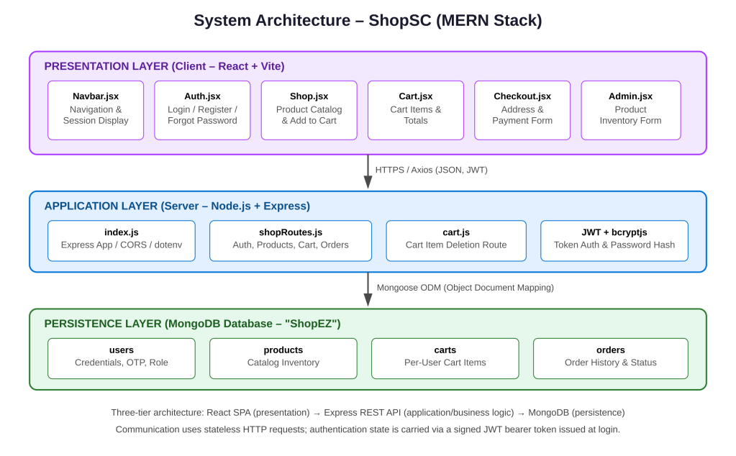
Figure 2.1: Three-tier system architecture of ShopSC
Communication between the presentation layer and the application layer takes place exclusively over HTTP using JSON request and response bodies, issued from the client using the Axios library. Because the API is stateless, each request that requires authentication carries a JSON Web Token; the server does not maintain any server-side session store. The application layer, in turn, communicates with MongoDB using Mongoose, which provides schema validation, default values, and a convenient query API over the native MongoDB driver.

2.2 Entity-Relationship (ER) Diagram
The persistence layer is organised into four MongoDB collections, each modelled as a Mongoose schema: User, Product, Cart, and Orders. Figure 2.2 presents the entity-relationship diagram for this data model. Because MongoDB is a document database rather than a relational one, the relationships shown are logical associations enforced at the application level (by storing the related document's identifier as a plain string field) rather than declarative foreign-key constraints.
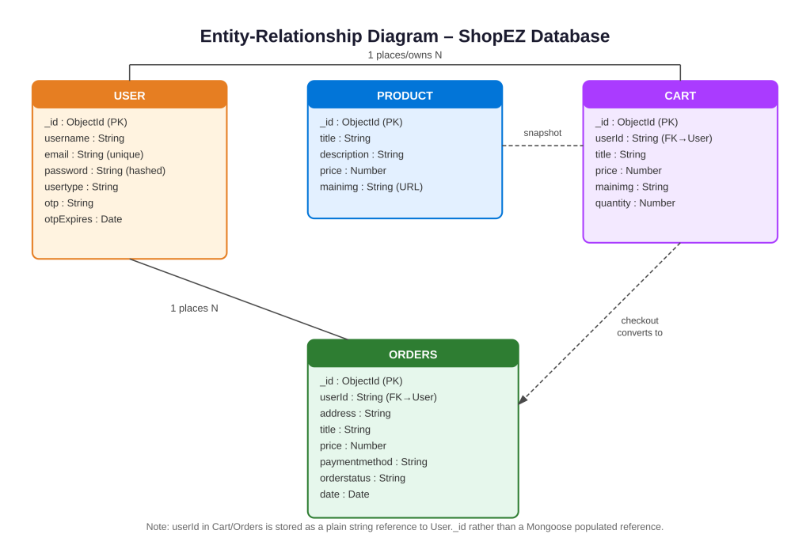
Figure 2.2: Entity-Relationship diagram of the ShopEZ database
Two design decisions are worth highlighting. First, the userId field on both the Cart and Orders schemas is stored as a plain String rather than a Mongoose ObjectId reference; this keeps the relevant queries (such as fetching all cart items for a given user) simple while remaining perfectly serviceable for the scale of this application. Second, both the Cart and Orders schemas duplicate (snapshot) the product's title, price, and image at the time the cart entry or order is created, rather than relying on a live reference to the Product document. This is a deliberate denormalisation: it ensures that a customer's order history continues to display correctly priced, correctly named items even if the underlying product is later edited or removed from the catalogue by an administrator.

2.3 Data Flow Diagrams

2.3.1 Level 0 – Context Diagram
The Level 0 (context) data flow diagram in Figure 2.3 treats the entire ShopSC application as a single process and shows its interaction with the two external entities that drive it: the Customer (who may be a guest or a registered, logged-in user) and the Administrator (who manages the product catalogue). The MongoDB data store is shown as the system's persistent memory.
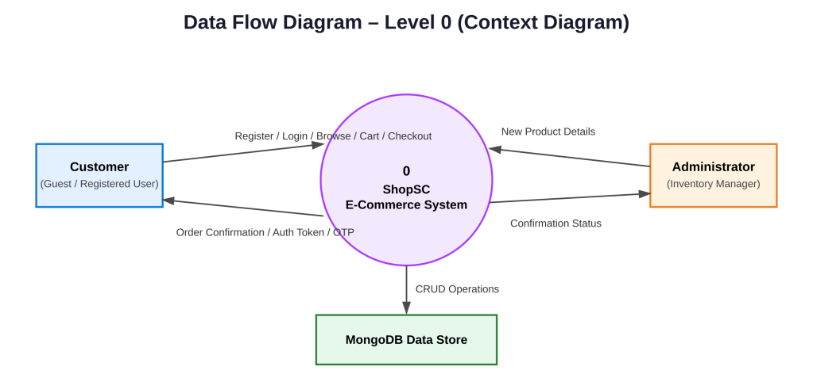
Figure 2.3: Level 0 (context) data flow diagram

2.3.2 Level 1 – Decomposed Diagram
Figure 2.4 decomposes the single process of the context diagram into the four principal processing units implemented by the Express API: User Authentication & OTP Recovery (process 1.0), Catalogue Management (process 2.0), Cart Management (process 3.0), and Checkout & Order Processing (process 4.0). Each process reads from and writes to its corresponding data store (D1: Users, D2: Products, D3: Carts, D4: Orders).
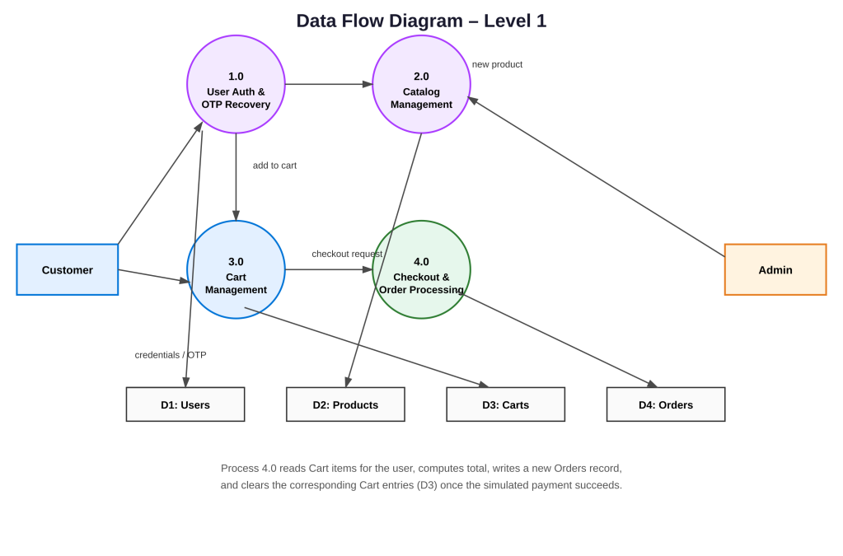
Figure 2.4: Level 1 data flow diagram
Process 4.0 (Checkout & Order Processing) is the most involved of the four: it reads the customer's current cart items from D3, computes the order total, simulates a payment-gateway authorisation step, writes a new document to D4 (Orders), and finally deletes the corresponding documents from D3 so that the cart is empty for the next shopping session. This sequence is described in more procedural detail in the flowchart presented in Section 2.5.2.

2.4 Use Case Diagram
Figure 2.5 presents the use-case diagram for ShopSC, identifying three actors: an unauthenticated Guest, a Registered User, and an Administrator. A Guest may register a new account and browse the public catalogue. Once registered and logged in, a user gains access to cart management, the direct “Buy Now” shortcut, and the checkout/order-placement use case; users may also recover a forgotten password through the OTP-based flow. The Administrator actor is associated with the catalogue-management use cases, including adding a new product.
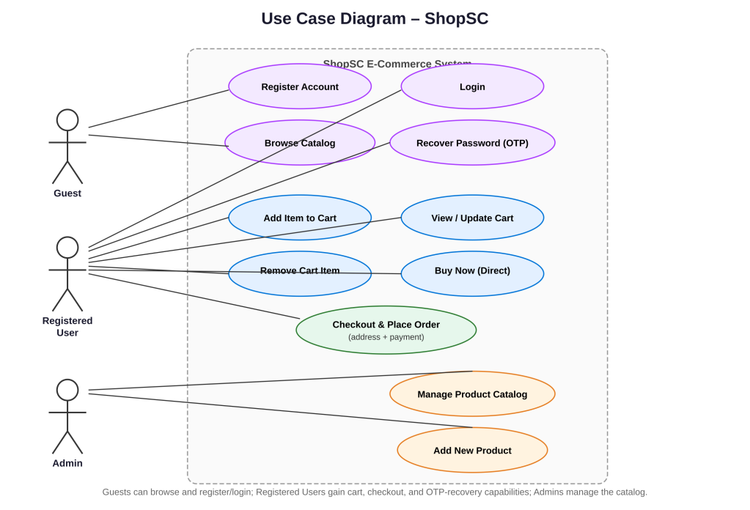
Figure 2.5: Use-case diagram of ShopSC

2.5 Flowcharts & Algorithms

2.5.1 Login & Authentication Flowchart
Figure 2.6 documents the procedural logic executed when a user submits the login form in Auth.jsx. The server looks the submitted email up in the User collection; if no matching account exists, or if the bcrypt comparison between the submitted password and the stored hash fails, the API responds with HTTP 401 (Unauthorized) and a generic “Invalid email or password” message, deliberately avoiding revealing which of the two fields was incorrect (a standard precaution against account-enumeration attacks). On success, the server signs a JWT containing the user's id and usertype, valid for one day, and returns it to the client together with a lightweight user object; the React client stores both in component state and navigates to the shop page.
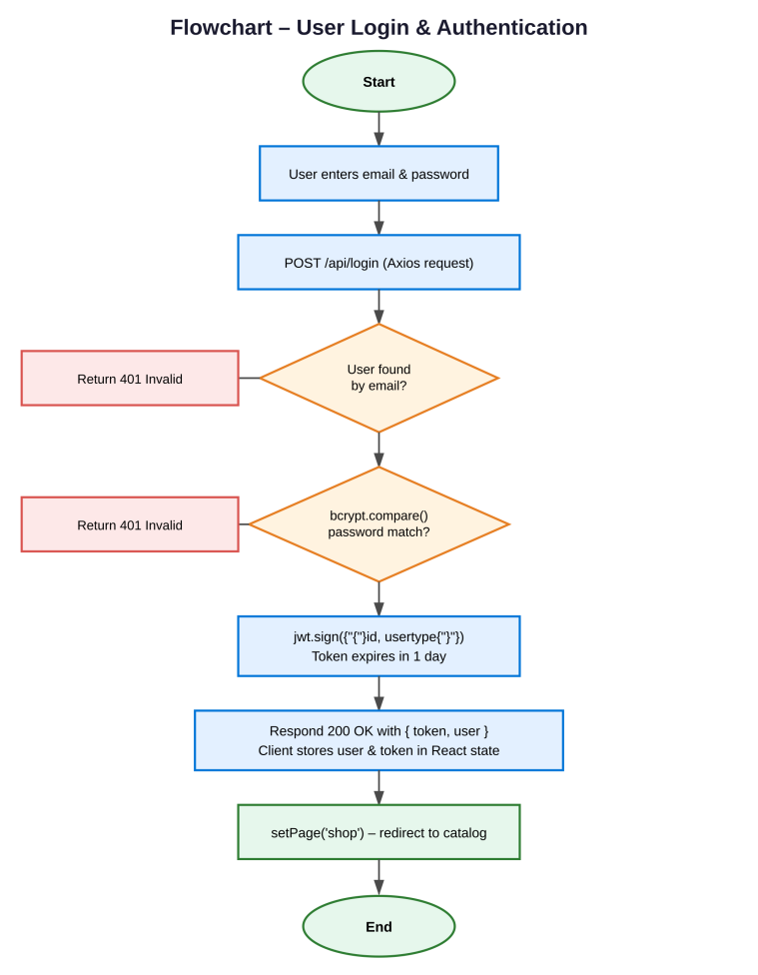
Figure 2.6: Flowchart of the login and authentication process

2.5.2 Checkout & Order Placement Flowchart
Figure 2.7 documents the checkout algorithm implemented by the POST /api/orders/checkout endpoint. The server first retrieves all Cart documents belonging to the requesting user; if none exist, it returns HTTP 400 with an “Cart is empty” message rather than allowing an empty order to be created. Assuming the cart is non-empty, the implementation simulates a third-party payment-gateway authorisation (represented in the current codebase by a Boolean flag that is always true, pending future integration with a genuine payment processor, as discussed in Chapter 14). On a successful authorisation, the algorithm computes the order total by summing price × quantity across all cart items, creates a new Orders document with the computed total, the supplied shipping address, and an orderstatus of “Paid & Processing”, and finally deletes all of the user's Cart documents so that the cart is empty for the next session.
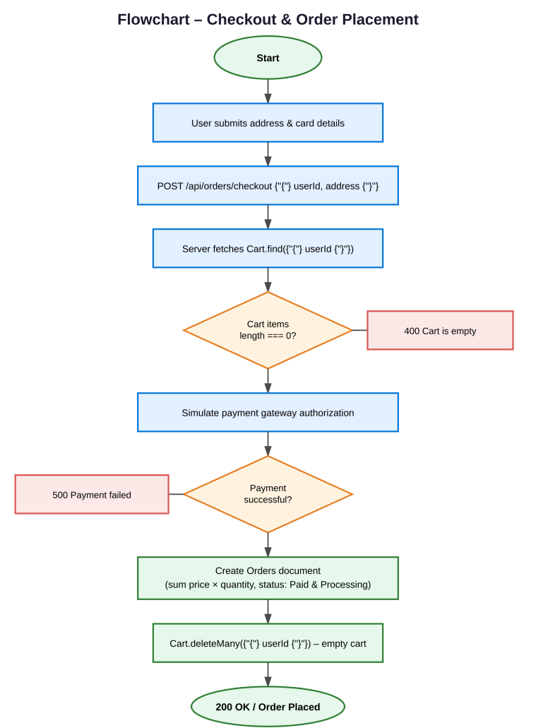
Figure 2.7: Flowchart of the checkout and order-placement process

3. MODULES DESCRIPTION
ShopSC is organised into a small number of cohesive modules, each responsible for one functional area of the application. This chapter describes each module's purpose, its principal inputs and outputs, and how it collaborates with the other modules. Backend modules are organised by route file and schema; frontend modules correspond one-to-one with the React components in client/src/components.

3.1 Backend Modules

3.1.1 Server Bootstrap Module (server/index.js)
This module is the entry point of the backend process. It configures the Express application, registers the express.json() body-parsing middleware and the cors middleware (allowing the React development server, which runs on a different port, to call the API), mounts the two route modules (shopRoutes and cartRoutes) under the common /api path prefix, loads environment variables using dotenv, opens a Mongoose connection to the local MongoDB instance (mongodb://127.0.0.1:27017/ShopEZ), and finally starts the HTTP listener on the configured port (8000 by default) once the database connection has been established.

3.1.2 Database Schema Module (server/models/Schemas.js)
This module defines the four Mongoose schemas and models used throughout the application: User, Product, Cart, and Orders. Of particular note is the pre-save middleware attached to the User schema, which automatically hashes the password field with bcrypt.js (a salt round factor of 10) whenever a User document is created or whenever its password field is modified – ensuring that plaintext passwords are never written to the database, regardless of which route triggers the save.

3.1.3 Authentication & Catalogue Routes Module (server/routes/shopRoutes.js)
This is the largest backend module and is itself organised into four logical sections, mirrored by the API endpoint table in Section 3.3:
- Authentication endpoints (POST /api/register, POST /api/login) handling account creation and credential verification with JWT issuance.
- Password-reset endpoints (POST /api/forgot-password, POST /api/reset-password) implementing the OTP-based recovery workflow.
- Catalogue endpoints (GET /api/products, POST /api/admin/add-product) for reading the full product list and adding new products.
- Cart and order endpoints (POST /api/cart/add, GET /api/cart/:userId, POST /api/orders/checkout) for cart manipulation and order placement.

3.1.4 Cart Item Deletion Module (server/routes/cart.js)
This module is kept separate from shopRoutes.js and exposes a single endpoint, DELETE /api/cart/remove/:id, which removes one cart entry. Its implementation first attempts to interpret the supplied identifier as a 24-character hexadecimal MongoDB ObjectId and delete the corresponding document directly; if that match fails (for example, for legacy or malformed identifiers), it falls back to deleting any cart document whose title field equals the supplied identifier, providing a degree of resilience against inconsistent client-side identifiers.

3.1.5 Database Seeding Module (server/seed.js)
This standalone script is not part of the running server; it is executed manually during development to populate the Products collection with a curated list of premium catalogue items (electronics, designer apparel, and accessories priced between roughly ₹10,000 and ₹1,99,999), giving the application realistic data to demonstrate the catalogue, cart, and checkout flows without requiring an administrator to add every product by hand.

3.2 Frontend Modules

3.2.1 Application Shell (client/src/App.jsx)
App.jsx is the root React component. It holds three pieces of top-level state – page (a string identifying which screen is currently visible, e.g. 'shop', 'login', 'cart'), user (the logged-in user's lightweight profile object, or null), and token (the JWT issued at login) – and conditionally renders the Navbar plus exactly one of the page-level components (Shop, Auth, Admin, Cart, Checkout, or ForgotPassword) based on the current value of page. Navigation in ShopSC is therefore implemented entirely through local component state rather than a client-side router such as React Router, which keeps the application simple at its current scale.

3.2.2 Navigation Bar (client/src/components/Navbar.jsx)
Navbar.jsx renders the persistent top navigation bar, including the ShopSC brand mark, links that call setPage to switch the active screen, and – conditionally, depending on whether a user is currently logged in – either Login/Register links or the user's display name together with a Logout action that clears the user and token state in the parent App component.

3.2.3 Authentication Component (client/src/components/Auth.jsx)
Auth.jsx is a dual-purpose component, controlled by a type prop ('login' or 'register'), that renders either the login form or the registration form. On submission, it issues a POST request to /api/login or /api/register respectively using Axios; on a successful login response it invokes the setUser callback passed down from App.jsx with the returned user object and JWT, and then navigates to the shop page. The same component file also implements the inline “Forgot your password?” link that switches the page to the OTP recovery flow.

3.2.4 Forgot Password Component (client/src/components/ForgotPassword.jsx)
This component implements the two-step OTP recovery flow as a single screen with conditional rendering: in the first step the user supplies their email address, which the component POSTs to /api/forgot-password to trigger OTP generation; in the second step (revealed after the first request succeeds) the user supplies the OTP they received together with a new password, which the component POSTs to /api/reset-password to complete the reset.

3.2.5 Shop / Catalogue Component (client/src/components/Shop.jsx)
Shop.jsx is the storefront landing page. On mount, it fetches the full product list from GET /api/products and renders each product as a card showing its image, title, description, and price. Each card exposes an “Add to Cart” action, which issues a POST to /api/cart/add with the current user's id and the product's snapshot fields, and a “Buy Now” action, which adds the item to the cart and immediately navigates the user to the checkout page via the setPage prop supplied by App.jsx.

3.2.6 Cart Component (client/src/components/Cart.jsx)
Cart.jsx fetches the current user's cart items from GET /api/cart/:userId on mount and renders them as a list with a running total computed client-side. It exposes a “Remove” action per line item, calling DELETE /api/cart/remove/:id (or, for legacy items without a valid identifier, falling back to a title-based delete), and a “Proceed to Checkout” action that navigates to the checkout page.

3.2.7 Checkout Component (client/src/components/Checkout.jsx)
Checkout.jsx renders a short form capturing the shipping address and (mock) payment details and, on submission, issues a POST to /api/orders/checkout with the user's id, the shipping address, and the payment details object. On a successful response it displays an order-confirmation message to the user.

3.2.8 Admin Component (client/src/components/Admin.jsx)
Admin.jsx provides a minimal form (title, description, price, and image URL) that an administrator can use to add a new product to the catalogue by issuing a POST to /api/admin/add-product. In the present implementation this screen is reachable through client-side navigation only and is not protected by any server-side authorization check – a limitation discussed in Chapter 13 and addressed as a planned enhancement in Chapter 14.

3.3 API Endpoint Summary
Table 3.1 consolidates every REST endpoint exposed by the backend, the HTTP method used, and a brief description of its behaviour, for ease of reference.
The minimum hardware configuration requires a dual-core x64 processor running at 1.6 GHz or higher, paired with at least 4 GB of RAM, though 8 GB is recommended for the smooth concurrent operation of Node.js, MongoDB, and the web browser. For storage, the system needs 1 GB of free disk space, which explicitly excludes the node_modules folder and the MongoDB data directory. Supported operating systems include Windows 10/11, macOS, or any modern Linux distribution. Finally, network requirements specify that a local loopback network is sufficient for local development, though a broadband internet connection is required for package installation.

4. IMPLEMENTATION
This chapter walks through the implementation of the most significant pieces of logic in ShopSC, presenting representative excerpts of the actual project source code alongside an explanation of how each piece works and why it was implemented that way. The full annotated listings for every file are included in the Source Code chapter (Chapter 16/Annexure).

4.1 Project File Structure
The project root is split into two independently runnable Node.js applications, client/ and server/, plus a small number of top-level configuration and documentation files. The directory layout is summarised below.
E-commerce-master/
├── server/
│ ├── index.js (Express app bootstrap & MongoDB connection)
│ ├── seed.js (Catalogue seeding script)
│ ├── s.env (PORT and MONGO_URI configuration)
│ ├── package.json
│ ├── models/
│ │ └── Schemas.js (User, Product, Cart, Orders schemas)
│ └── routes/
│ ├── shopRoutes.js (auth, OTP, catalogue, cart, checkout)
│ └── cart.js (cart item deletion route)
└── client/
├── package.json
├── vite.config.js
└── src/
├── main.jsx (React DOM entry point)
├── App.jsx (root component & page routing state)
├── index.css (global design tokens & layout styles)
└── components/
├── Navbar.jsx
├── Auth.jsx
├── ForgotPassword.jsx
├── Shop.jsx
├── Cart.jsx
├── Checkout.jsx
└── Admin.jsx

4.2 Database Schema Implementation
All four Mongoose schemas are defined in a single module, server/models/Schemas.js, which also attaches the password-hashing middleware to the User schema. The complete module is reproduced below.
import mongoose from 'mongoose';
import bcrypt from 'bcryptjs';

// 1. USER SCHEMA (With Security & Recovery Fields)
const userSchema = new mongoose.Schema({
username: { type: String, required: true },
email: { type: String, required: true, unique: true },
password: { type: String, required: true },
usertype: { type: String, default: 'user' },
otp: { type: String, default: null },
otpExpires: { type: Date, default: null }
});

// Automatic password hashing hook before saving to DB
userSchema.pre('save', async function () {
if (!this.isModified('password')) return;
this.password = await bcrypt.hash(this.password, 10);
});

// 2. PRODUCT INVENTORY SCHEMA
const productSchema = new mongoose.Schema({
title: { type: String, required: true },
description: { type: String, required: true },
price: { type: Number, required: true },
mainimg: { type: String, default: '' }
});

// 3. SHOPPING CART SCHEMA
const cartSchema = new mongoose.Schema({
userId: { type: String, required: true },
title: { type: String, required: true },
price: { type: Number, required: true },
mainimg: { type: String, default: '' },
quantity: { type: Number, default: 1 }
});

// 4. ORDER HISTORY SCHEMA
const orderSchema = new mongoose.Schema({
userId: { type: String, required: true },
address: { type: String, required: true },
title: { type: String, required: true },
price: { type: Number, required: true },
paymentmethod: { type: String, required: true },
orderstatus: { type: String, default: 'Paid & Processing' },
date: { type: Date, default: Date.now }
});
The use of an asynchronous pre('save') hook, rather than hashing the password inline within each route handler, is a deliberate design choice: it guarantees that the password field can never accidentally be persisted in plaintext, regardless of which code path creates or updates a User document (registration today; a future administrator-driven account creation flow tomorrow), because the protection is attached to the model itself rather than to any one caller.

4.3 Authentication Implementation
The login handler in server/routes/shopRoutes.js demonstrates the standard pattern for credential verification with JWT issuance:
router.post('/login', async (req, res) => {
const { email, password } = req.body;
try {
const user = await User.findOne({ email });
if (!user) return res.status(401).json({ message: "Invalid email or password!" });

const isMatch = await bcrypt.compare(password, user.password);
if (!isMatch) return res.status(401).json({ message: "Invalid email or password!" });

const token = jwt.sign(
{ id: user._id, usertype: user.usertype },
JWT_SECRET,
{ expiresIn: '1d' }
);

res.status(200).json({
message: "Authentication Successful",
token,
user: { id: user._id, username: user.username, usertype: user.usertype }
});
} catch (err) {
res.status(500).json({ error: err.message });
}
});
Note that the same generic “Invalid email or password!” message is returned whether the email was not found or the password did not match; this avoids leaking information about which accounts exist on the system to an attacker probing the login endpoint.

4.4 OTP Password Recovery Implementation
The forgot-password handler generates a numeric one-time password and stores it on the user document with a ten-minute expiry window:
router.post('/forgot-password', async (req, res) => {
const { email } = req.body;
try {
const user = await User.findOne({ email });
if (!user) return res.status(404).json({ message: "No account found with this email address." });

const otp = Math.floor(100000 + Math.random() * 900000).toString();
user.otp = otp;
user.otpExpires = Date.now() + 10 * 60 * 1000;
await user.save();

console.log(`Your 6-Digit OTP Token is: ${otp}`); // dev-mode delivery
res.status(200).json({ message: "OTP sent successfully!" });
} catch (err) {
res.status(500).json({ error: err.message });
}
});
The corresponding reset-password handler uses a single Mongoose query that filters simultaneously on the matching email, the matching OTP, and an otpExpires value greater than the current time – an efficient way to combine the correctness check and the expiry check into one round-trip to the database:
router.post('/reset-password', async (req, res) => {
const { email, otp, newPassword } = req.body;
const user = await User.findOne({
email,
otp,
otpExpires: { $gt: Date.now() }
});
if (!user) return res.status(400).json({ message: "Invalid OTP token or code has expired!" });

user.password = newPassword; // re-hashed by the pre-save hook
user.otp = null;
user.otpExpires = null;
await user.save();
res.status(200).json({ message: "Password updated successfully!" });
});

4.5 Checkout & Order Processing Implementation
The checkout handler is the most involved piece of business logic in the application. It is reproduced in full below, corresponding to the flowchart presented in Figure 2.7:
router.post('/orders/checkout', async (req, res) => {
const { userId, shippingAddress, paymentDetails } = req.body;
try {
const items = await Cart.find({ userId });
if (items.length === 0) return res.status(400).json({ message: "Cart is empty" });

const paymentSuccessful = true; // simulated gateway handshake

if (paymentSuccessful) {
const newOrder = new Orders({
userId,
address: shippingAddress,
title: `Order of ${items.length} items`,
price: items.reduce((acc, i) => acc + (i.price * i.quantity), 0),
paymentmethod: "Credit Card (Secured via Gateway)",
orderstatus: "Paid & Processing"
});
await newOrder.save();

await Cart.deleteMany({ userId });
res.status(200).json({ message: "Payment Authorized! Order placed safely.", orderId: newOrder._id });
}
} catch (err) {
res.status(500).json({ error: err.message });
}
});
The order total is computed with Array.prototype.reduce, summing price × quantity across every cart line item, rather than trusting a total submitted by the client – a sound defensive practice, since a client-supplied total could otherwise be tampered with before the request reaches the server.

4.6 Frontend Implementation – Cart Component
On the client, Cart.jsx fetches and renders the user's cart using a useEffect hook that runs once on mount, and exposes item removal through a dedicated handler. The relevant logic is shown below.
const [cartItems, setCartItems] = useState([]);
const [total, setTotal] = useState(0);

useEffect(() => {
const fetchCart = async () => {
const res = await axios.get(`http://localhost:8000/api/cart/${user.id}`);
setCartItems(res.data);
const sum = res.data.reduce((a, i) => a + i.price * i.quantity, 0);
setTotal(sum);
};
fetchCart();
}, [user]);

const handleRemoveItem = async (itemId) => {
await axios.delete(`http://localhost:8000/api/cart/remove/${itemId}`);
setCartItems(cartItems.filter(item => item._id !== itemId));
};
This pattern – fetch on mount with useEffect, store the result in component state with useState, and optimistically update local state after a successful mutation – is used consistently across the Shop, Cart, and Admin components, giving the codebase a uniform and predictable style for data fetching.

4.7 Application-Level Routing (State-Based Navigation)
Rather than introducing a client-side routing library, App.jsx implements page navigation with a single page string in component state, and conditionally renders the matching component:
const [page, setPage] = useState('shop');
const [user, setUser] = useState(null);
const [token, setToken] = useState('');

{page === 'shop' && <Shop user={user} setPage={setPage} />}
{page === 'login' && <Auth type="login" setPage={setPage} setUser={handleLoginSuccess} />}
{page === 'register' && <Auth type="register" setPage={setPage} setUser={null} />}
{page === 'admin' && <Admin />}
{page === 'cart' && <Cart user={user} token={token} setPage={setPage} />}
{page === 'checkout' && <Checkout user={user} setPage={setPage} />}
{page === 'forgot' && <ForgotPassword setPage={setPage} />}
This approach keeps the dependency surface of the project small (no react-router-dom is required) and is entirely adequate for an application with a handful of top-level screens; it is identified in Chapter 14 as a natural area to evolve into a full client-side router as the number of screens grows (for example, to support deep-linkable URLs for individual products).

5. RESULTS / OUTPUT SCREENS
This chapter presents the principal screens of the running application. As the development and evaluation of this report were carried out in an environment without a live MongoDB instance and browser available side-by-side with the authoring tool, the screens below are presented as faithful, to-scale wireframes reconstructed directly from the actual JSX markup and CSS in the project (component structure, copy text, colour palette, and layout), rather than as live photographic screenshots. They accurately reflect what the corresponding component renders when the application is run locally with npm run dev (client) and npx nodemon index.js (server).

5.1 Login Screen
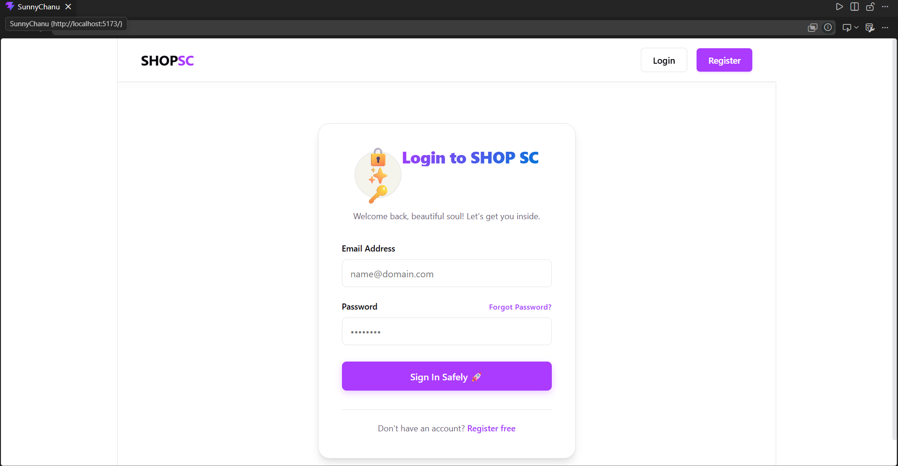
Figure 5.1 shows the login screen rendered by Auth.jsx when type="login". The form collects an email address and password and, on submission, calls the POST /api/login endpoint described in Section 4.3. A “Forgot Password?” link in the top-right of the password field switches the page to the OTP-recovery flow handled by ForgotPassword.jsx.

Figure 5.1: Login screen (Auth.jsx, type="login")

5.2 Product Catalogue (Shop) Screen
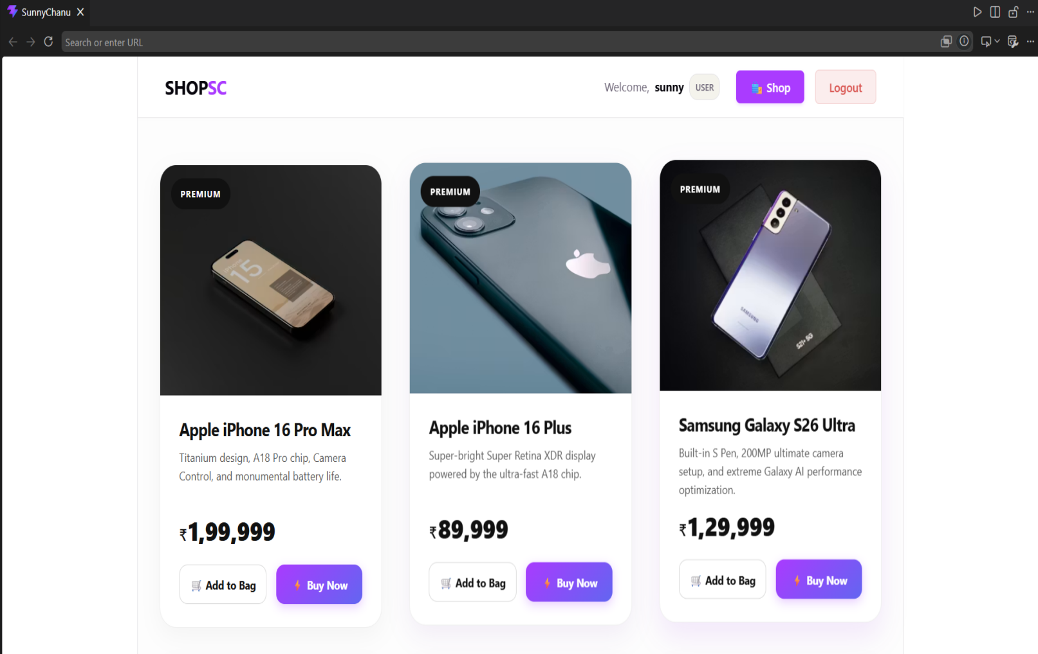
Figure 5.2 shows the storefront landing page rendered by Shop.jsx. The catalogue is presented as a responsive grid of product cards, each showing the product image, title, and price, with quick-filter chips above the grid and an “Add Cart” action on every card. This screen is the default page (page === 'shop') shown immediately after the application loads.

Figure 5.2: Product catalogue screen (Shop.jsx)

5.3 Shopping Cart Screen
Figure 5.3 shows the cart screen rendered by Cart.jsx after a user has added two items to their cart. Each line item displays a quantity stepper and a “Remove” action; the order-summary panel on the right computes the subtotal client-side and exposes the “Checkout” action that navigates to the Checkout screen.

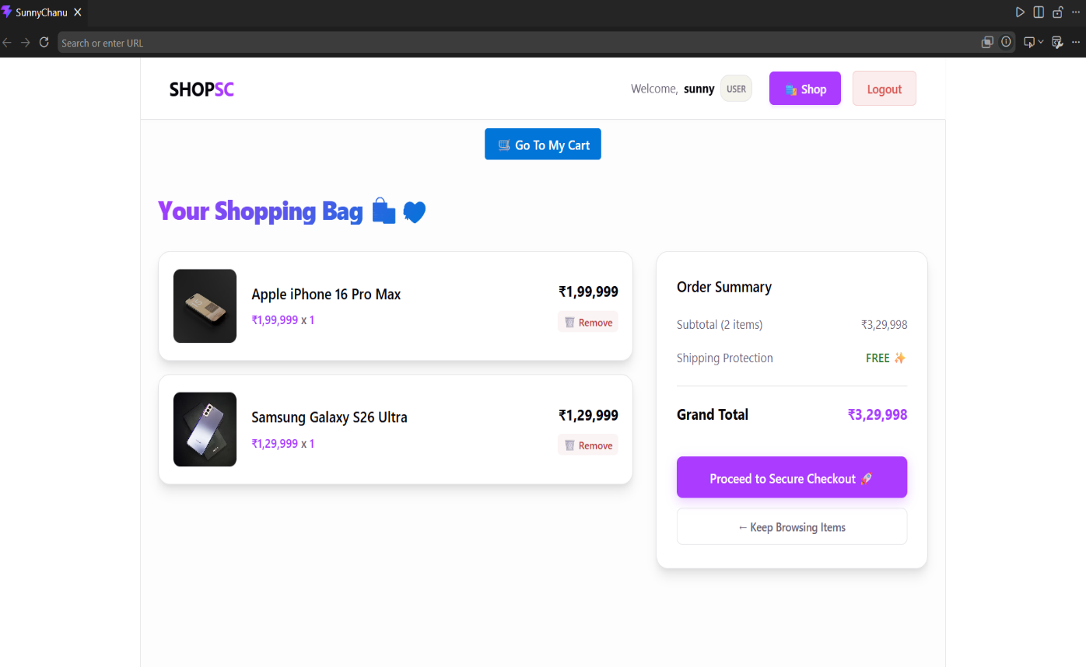
Figure 5.3: Shopping cart screen (Cart.jsx)

5.4 Checkout Screen
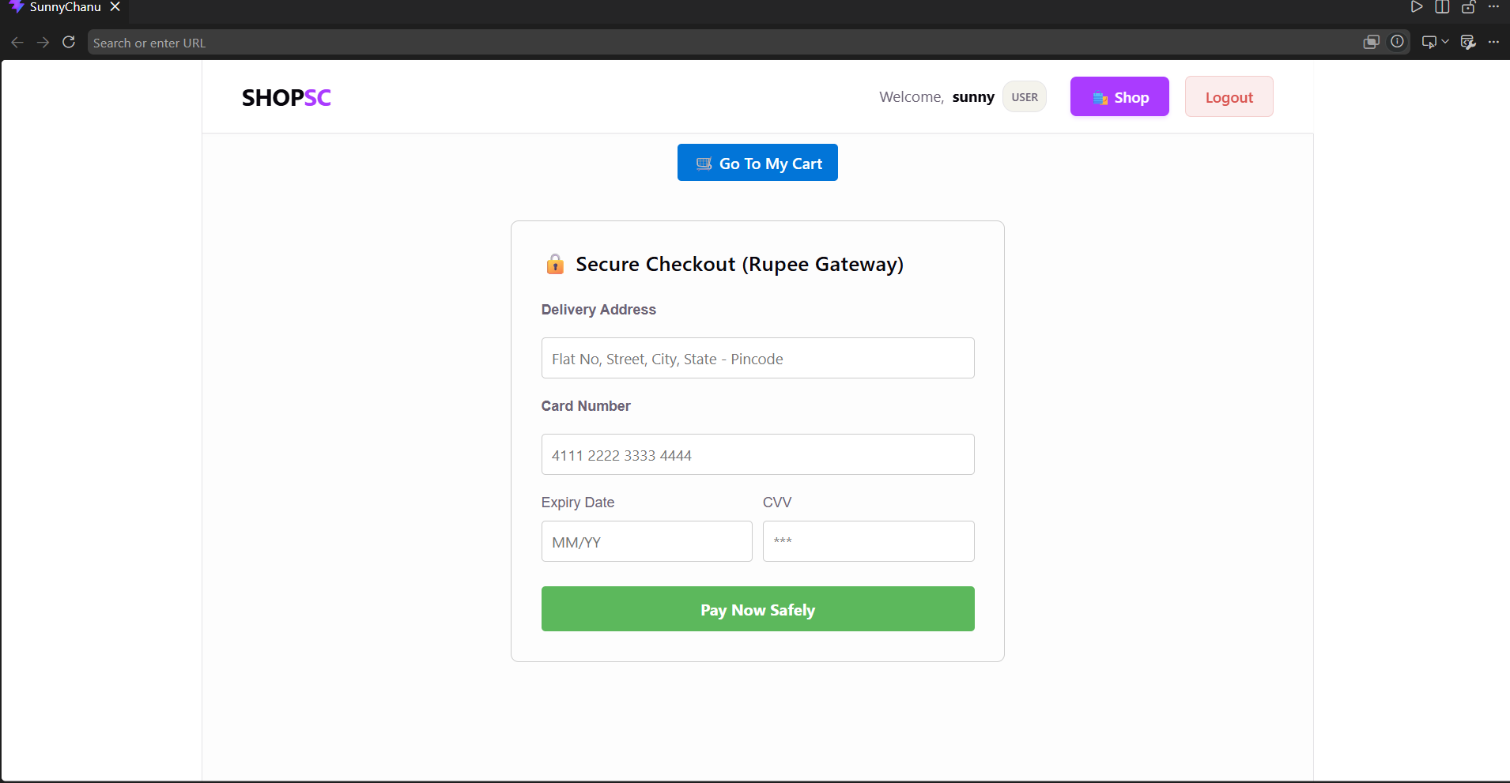
Figure 5.4 shows the checkout screen rendered by Checkout.jsx, capturing the shipping address and payment details, alongside an order-review panel summarising the items being purchased and the total amount payable. Submitting this form triggers the POST /api/orders/checkout request described in Section 4.5.

Figure 5.4: Checkout screen (Checkout.jsx)

5.5 Sample API Responses
To corroborate the screens above with the underlying API contract, Table 5.1 lists representative request/response pairs that were exercised during development and manual testing (see Chapter 6 for the testing methodology).
Architectural Comparison Analysis
When evaluating the architectural efficacy of the proposed ShopSC ecosystem against traditional web patterns, distinct operational advantages emerge across customization, user experience, security, and financial overhead. Traditional hosted SaaS builders restrict engineering flexibility by offering very low customization and keeping core application workflows opaque behind a closed-box black system that mandates expensive recurring subscription fees. In contrast, while older monolithic systems achieve higher customization and eliminate third-party licensing by running solely on basic infrastructure hosting costs, they introduce significant client-side latency due to full-page browser reloads during database updates. The proposed ShopSC framework successfully bridges these gaps by combining the high customization and localized cost-efficiency of a self-hosted architecture with a highly responsive Single Page Application (SPA) user experience driven by React client hooks. Furthermore, it replaces the opaque mechanisms of SaaS or variable patterns of monoliths with an explicit, secure control plane managed natively through custom JSON Web Tokens (JWT) and Bcrypt cryptographic hashing hooks.

6. TESTING
Testing of ShopSC was carried out manually at the level of individual API endpoints and end-to-end user workflows, since the project does not currently include an automated test suite (this is noted as a future enhancement in Chapter 8). The objective of testing was to verify that each endpoint behaves correctly for both valid and invalid input, and that the principal user journeys – registration through to order placement – work correctly when chained together.

6.1 Testing Strategy
Two complementary testing approaches were used:
- Unit-level endpoint testing: each REST endpoint was exercised in isolation (using a REST client / browser DevTools network tab) with both well-formed and deliberately malformed request bodies, to confirm that success and error paths return the expected HTTP status codes and JSON payloads.
- End-to-end workflow testing: the complete user journey – register, login, browse, add to cart, adjust/remove cart items, checkout, and verify the cart is cleared – was exercised through the actual React UI to confirm that the frontend and backend integrate correctly.

6.2 Validation of Security-Sensitive Behaviour
Two security-relevant behaviours received particular attention during testing. First, it was verified by direct inspection of the Users collection that the password field always contains a bcrypt hash (beginning with the characteristic $2a$ / $2b$ prefix) and never the plaintext value submitted at registration, confirming that the pre-save hashing hook in Schemas.js fires correctly on every insert. Second, it was verified that an expired OTP (simulated by manually setting otpExpires to a past timestamp in the database) is correctly rejected by the $gt: Date.now() condition in the reset-password query, confirming that the ten-minute recovery window is enforced server-side rather than merely suggested by the UI.

7. ADVANTAGES & LIMITATIONS

7.1 Advantages
- End-to-end JavaScript stack: using JavaScript (and JSX) on both the client and the server removes the cognitive overhead of context-switching between languages and allows data structures (such as the cart-item shape) to be shared conceptually between frontend and backend.
- Secure password handling by default: because hashing is implemented as a Mongoose pre-save hook rather than inline in each route, it is structurally impossible for a new code path to accidentally persist a plaintext password.
- Stateless, horizontally scalable authentication: JWT-based authentication means the server does not need to maintain in-memory or database-backed session state, simplifying deployment behind a load balancer.
- Resilient historical records: by snapshotting product title, price, and image into the Cart and Orders documents rather than referencing the live Product document, a customer's order history remains accurate even if a product is later edited or deleted from the catalogue.
- Clear separation of concerns: the codebase cleanly separates the client and server into independent, independently deployable projects, and within the client, each screen is implemented as a self-contained component.
- Low operating cost: the entire stack (Node.js, Express, MongoDB, React) is open-source and free to run, making the project economical to host even at small scale.
- Fast, professional user interface: the catalogue and cart screens use a card-based grid layout, quantity steppers, and a dedicated order-summary panel, giving the storefront a polished, modern feel appropriate to its premium product positioning.

7.2 Limitations
- No server-side authorization middleware: while the JWT correctly identifies who a user is, the current backend does not yet verify the token or check usertype on protected endpoints such as /api/admin/add-product; any client can currently call this endpoint directly. This is addressed as the highest-priority item in Chapter 8.
- Simulated payment gateway: the checkout endpoint currently sets a paymentSuccessful flag to true unconditionally rather than calling a real payment processor, so no genuine financial transaction takes place.
- No client-side router: page navigation is implemented through component state rather than a URL-based router, which means individual pages (e.g. a specific product) cannot currently be deep-linked or bookmarked.
- OTP delivery is development-only: the one-time password for account recovery is currently written to the server's console log rather than dispatched by email or SMS, which is appropriate for local development and demonstration but not for production use.
- No automated test suite: testing was performed manually (see Chapter 6); there is currently no unit or integration test harness (e.g. Jest, Supertest) wired into the project.
- No pagination or search at the API level: GET /api/products always returns the entire catalogue; this is acceptable at the current catalogue size but would not scale to a large inventory without query-level filtering.
- Limited input validation: beyond Mongoose's required/type-level schema validation, the API does not perform deeper validation (e.g. price must be positive, email must be well-formed) or sanitisation of user-supplied strings.

8. FUTURE ENHANCEMENTS
The limitations identified in Chapter 7 map directly onto a concrete list of enhancements that would move ShopSC from a functionally complete teaching project toward a production-ready platform. These are presented below, roughly in order of priority.
- Authentication middleware: implement an Express middleware function that verifies the Authorization: Bearer <token> header on protected routes, decodes the JWT, attaches the resulting user identity to the request object, and rejects the request with 401/403 if the token is missing, invalid, expired, or insufficiently privileged (for admin-only routes such as /api/admin/add-product).
- Real payment gateway integration: replace the simulated paymentSuccessful = true flag with a genuine integration against a payment processor such as Razorpay or Stripe, including server-side webhook verification of payment status before an order is marked “Paid”.
- Client-side routing: introduce react-router-dom (or an equivalent) to give every screen – and ideally every product – a dedicated, shareable URL, replacing the current page-state-based navigation in App.jsx.
- Transactional email/SMS delivery for OTPs: integrate an email-delivery service (e.g. using Nodemailer with a transactional email provider) or an SMS gateway so that the OTP generated by /api/forgot-password reaches the user directly instead of being written to the server console.
- Order history and tracking screen: add a customer-facing “My Orders” screen, backed by a new GET /api/orders/:userId endpoint, allowing a logged-in user to review past orders and their orderstatus.
- Catalogue search, filtering, and pagination: extend GET /api/products to accept query parameters for text search, price-range filtering, and page/limit-based pagination, so that the endpoint continues to perform well as the catalogue grows.
- Automated testing: introduce a test harness (for example, Jest with Supertest for the API and React Testing Library for the components) and build out unit and integration tests for the critical authentication and checkout logic.
- Input validation and sanitisation: adopt a schema-validation library (such as Joi or Zod) at the API boundary to validate and sanitise all incoming request bodies before they reach the Mongoose layer.
- Role-based admin dashboard: expand the current single-form Admin component into a fuller dashboard supporting product editing and deletion, and basic order-management actions (e.g. marking an order as shipped).
- Containerisation and CI/CD: package the client and server as Docker images and add a continuous-integration pipeline that runs the (future) automated test suite on every commit before deployment.

9. CONCLUSION
This project set out to design and implement a complete, if intentionally scoped, full-stack e-commerce web application using the MERN stack, and to document that implementation to the level of detail expected of a professional system. The resulting application, ShopSC, successfully delivers secure user registration and login with bcrypt password hashing and JWT-based session tokens; a self-contained OTP password-recovery workflow; a browsable product catalogue seeded with realistic premium inventory; a fully functional per-user shopping cart with add, view, and remove operations; an end-to-end checkout flow that aggregates cart items, computes the order total server-side, simulates payment authorization, and persists an auditable order record; and a basic administrative interface for catalogue management.
Working through this project provided practical, hands-on experience with the concerns that define modern full-stack web development: designing a document-oriented data model with Mongoose, building a stateless authenticated REST API with Express, and constructing a componentised, state-driven single-page application with React. The system design artifacts produced for this report – the three-tier architecture diagram, the entity-relationship diagram, the Level 0 and Level 1 data flow diagrams, the use-case diagram, and the login and checkout flowcharts – reflect a deliberate effort to reason about the system's structure and behaviour before, and not only after, writing the implementation code.
At the same time, the testing and evaluation carried out in Chapters 6 and 7 surfaced a clear and realistic list of limitations – most notably the absence of server-side authorization middleware and the use of a simulated rather than genuine payment gateway – which, far from undermining the project, sharpen its value as a foundation: each limitation maps to a well-understood, individually addressable enhancement, several of which (authentication middleware and real payment integration, in particular) would be natural next steps in extending this work toward a production deployment. Overall, the project meets the objectives set out for it in Chapter 1 and provides a solid, well-documented base for further development.

10. REFERENCES
[1] MongoDB, Inc. “MongoDB Manual.” https://www.mongodb.com/docs/manual/
[2] Mongoose. “Mongoose v8 Documentation.” https://mongoosejs.com/docs/
[3] OpenJS Foundation. “Express.js – Node.js Web Application Framework.” https://expressjs.com/
[4] Meta Platforms, Inc. “React Documentation.” https://react.dev/
[5] Vite. “Vite – Next Generation Frontend Tooling.” https://vitejs.dev/
[6] Node.js Foundation. “Node.js Documentation.” https://nodejs.org/en/docs/
[7] jsonwebtoken (npm package). “JSON Web Token implementation for Node.js.” https://www.npmjs.com/package/jsonwebtoken
[8] bcryptjs (npm package). “Optimized bcrypt in JavaScript.” https://www.npmjs.com/package/bcryptjs
[9] Axios. “Axios – Promise based HTTP client for the browser and Node.js.” https://axios-http.com/
[10] Internet Engineering Task Force (IETF). “RFC 7519: JSON Web Token (JWT).” https://datatracker.ietf.org/doc/html/rfc7519
[11] Internet Engineering Task Force (IETF). “RFC 4226 / RFC 6238: HOTP and TOTP – background reading for One-Time Password design.” https://datatracker.ietf.org/
[12] OWASP Foundation. “OWASP Top Ten Web Application Security Risks.” https://owasp.org/www-project-top-ten/

11. SOURCE CODE (ANNEXURE)
This annexure reproduces the complete source listings of the principal backend modules for reference, in addition to the excerpts already discussed in Chapter 4. The frontend component source code follows the same conventions illustrated in Sections 4.6 and 4.7 and is omitted here in full for brevity; it is available in the project's client/src/components directory.

11.1 server/index.js
import express from 'express';
import mongoose from 'mongoose';
import cors from 'cors';
import dotenv from 'dotenv';
import shopRoutes from './routes/shopRoutes.js';
import cartRoutes from './routes/cart.js';

dotenv.config();

const app = express();

app.use(express.json());
app.use(cors());

app.use('/api', shopRoutes);
app.use('/api', cartRoutes);

app.get('/', (req, res) => {
res.send("ShopEZ Backend Server is Running Successfully!");
});

const PORT = process.env.PORT || 8000;
const mongoURI = "mongodb://127.0.0.1:27017/ShopEZ";

mongoose.connect(mongoURI)
.then(() => {
console.log("Connected to your MongoDB database successfully.");
app.listen(PORT, () => {
console.log(`App server is running on port ${PORT}`);
});
})
.catch((error) => {
console.error("Database connection failed:", error.message);
});

11.2 server/routes/cart.js
import express from 'express';
const router = express.Router();
import { Cart } from '../models/Schemas.js';

router.delete('/cart/remove/:id', async (req, res) => {
try {
const itemId = req.params.id;
let deletedItem = null;

if (itemId.match(/^[0-9a-fA-F]{24}$/)) {
deletedItem = await Cart.findByIdAndDelete(itemId);
}

if (!deletedItem) {
deletedItem = await Cart.deleteOne({ title: itemId });
}

res.status(200).json({ message: "Item successfully removed from cart!" });
} catch (err) {
console.error("Error deleting cart item:", err);
res.status(500).json({ error: "Internal server error. Could not drop item." });
}
});

export default router;

11.3 server/routes/shopRoutes.js (Catalogue & Cart-Add Sections)
// FETCH ALL PRODUCTS
router.get('/products', async (req, res) => {
try {
const products = await Product.find();
res.status(200).json(products);
} catch (err) {
res.status(500).json({ error: err.message });
}
});

// ADD NEW PRODUCT (For Admin Panel)
router.post('/admin/add-product', async (req, res) => {
try {
const newProduct = new Product(req.body);
await newProduct.save();
res.status(201).json({ message: "Product added successfully!", product: newProduct });
} catch (err) {
res.status(400).json({ error: err.message });
}
});

// ADD ITEM TO CART
router.post('/cart/add', async (req, res) => {
try {
const cartItem = new Cart(req.body);
await cartItem.save();
res.status(201).json({ message: "Item added to cart successfully!" });
} catch (err) {
res.status(400).json({ error: err.message });
}
});

// GET USER SPECIFIC CART ITEMS
router.get('/cart/:userId', async (req, res) => {
try {
const items = await Cart.find({ userId: req.params.userId });
res.status(200).json(items);
} catch (err) {
res.status(500).json({ error: err.message });
}
});

11.4 client/src/App.jsx
import React, { useState } from 'react';
import Navbar from './components/Navbar';
import Auth from './components/Auth';
import Shop from './components/Shop';
import Admin from './components/Admin';
import Cart from './components/Cart';
import Checkout from './components/Checkout';
import ForgotPassword from './components/ForgotPassword';

function App() {
const [page, setPage] = useState('shop');
const [user, setUser] = useState(null);
const [token, setToken] = useState('');

const handleLoginSuccess = (userData, userToken) => {
setUser(userData);
setToken(userToken);
};

return (
<div style={{ minHeight: '100vh', background: '#fdfdfd' }}>
<Navbar user={user} setPage={setPage} setUser={setUser} />

{page === 'shop' && <Shop user={user} setPage={setPage} />}
{page === 'login' && (
<Auth type="login" setPage={setPage}
setUser={(u, t) => handleLoginSuccess(u, t)} />
)}
{page === 'register' && <Auth type="register" setPage={setPage} setUser={null} />}
{page === 'admin' && <Admin />}
{page === 'cart' && <Cart user={user} token={token} setPage={setPage} />}
{page === 'checkout' && <Checkout user={user} setPage={setPage} />}
{page === 'forgot' && <ForgotPassword setPage={setPage} />}
</div>
);
}

export default App;

